**VPC NETWORKING LAB**

**Presentation**

GCP Virtual Private Cloud (VPC) provides networking capabilities for Compute Engine Virtual Machine (VM) instances, Kubernetes Engine containers, and the App Engine flexible environment. In other words, without a VPC network, you cannot create a VM instance, container, or App Engine application. Therefore, every GCP project has a **default** network to help you get started.

A VPC network is like a physical network except that it is virtualized in GCP. A VPC network is a global resource that consists of a list of regional virtual subnets hosted in data centers, which are linked together by a Wide Area Network (WAN). VPC networks are logically isolated from each other in GCP.

In this lab, you will create an automatic mode VPC network with firewall rules and two VM instances. You will then switch from automatic mode to custom mode and create other networks in custom mode, as shown in the diagram below. Finally, you will also test connectivity on different networks.

**Task 1: Explore the Default Network**

1. **Show subnets**

* *gcloud compute networks subnets list*

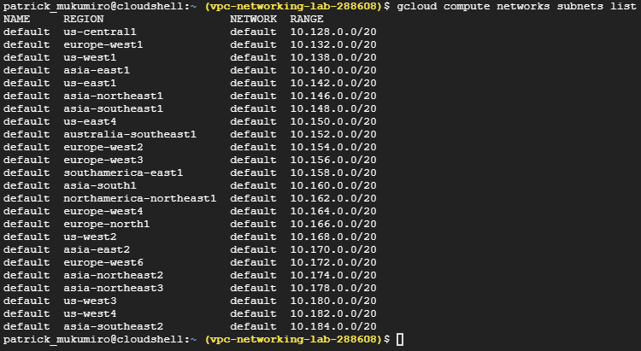

1. **Show routes**

* *gcloud compute routes list*

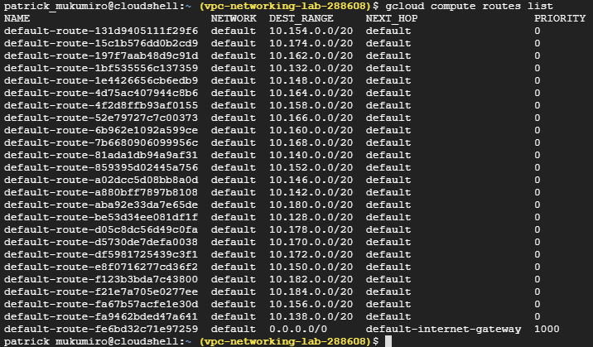

1. **View firewall rules**

* *gcloud compute firewall-rules list*

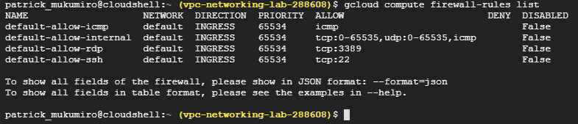

1. **Remove firewall rules**

* *gcloud compute firewall-rules delete default-allow-icmp*

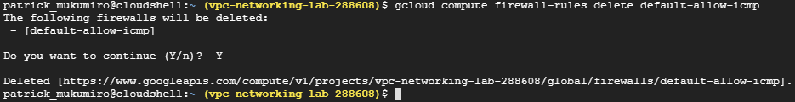

* *gcloud compute firewall-rules delete default-allow-internal*

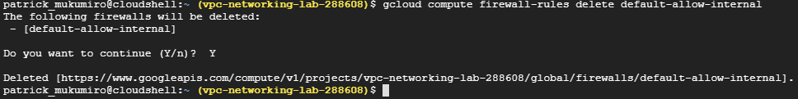

* *gcloud compute firewall-rules delete default-allow-rdp*

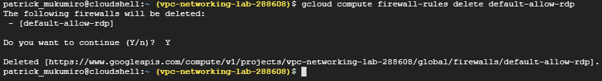

* *gcloud compute firewall-rules delete default-allow-ssh*

1. **Remove Default Network**

* *gcloud compute networks delete default*

1. **Try to create a VM instance**

* *gcloud beta compute instances create test --zone=us-central1-c --machine-type=n1-standard-1 --image=debian-9-stretch-v20200902 --image-project=debian-cloud --boot-disk-size=10GB --boot-disk-type=pd-standard --boot-disk-device-name=test --reservation-affinity=any*

**

As expected, you cannot create a VM instance without a VPC network.

**Task 2: Create a network in automatic mode**

1. **Create an automatic mode VPC network with firewall rules**

gcloud compute networks create mynetwork --project=vpc-networking-lab-288608 --subnet-mode=auto --bgp-routing-mode=regional

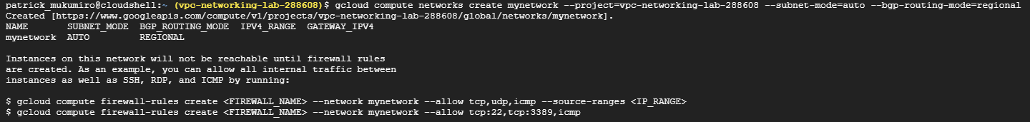

**Allow icmp, RDP, SSH, Internal**

1. **Create a VM instance in the us-central1 region**



1. **Create a VM instance in the europe-west1 region**



1. **Check connectivity of VM instances**

* Connection with ssh to mynet-us-vm

* Internal ping 10.132.0.2

* external ping 35.240.42.221

1. **Convert network to network in custom mode**

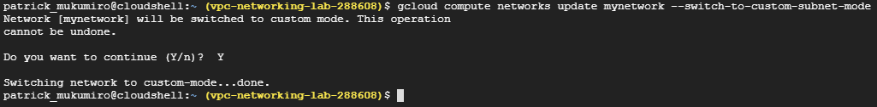

**Task 3: Create Networks in Custom Mode**

1. Create the ***managementnet*** network and ***managementnet-us*** subnet

1. Create the ***privatenet*** network

* Create the ***privatesubnet-us*** subnet*and* ***privatesubnet-eu*** subnet



* **To get a list of available VPC networks**

* **To get a list of available VPC subnets (sorted by VPC network)**

1. **Create the firewall rules for managementnet and for privatenet**

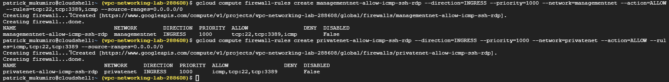

* **To get a list of firewall rules (sorted by VPC network)**

1. Create the **managementnet-us-vm** instance



1. Create the **privatenet-us-vm** instance



* To get the list of VM instances (sorted by zone)

**Task 4: Explore connectivity between networks**

1. **Pinging external IP addresses**

* Connection with ssh to mynet-us-vm

* Ping external **mynet-eu-vm**

* Ping external **managementnet-us-vm**

* Ping external **privatenet-us-vm**

1. **Pinging Internal IP addresses**

* Connection with ssh to mynet-us-vm

* Ping internal **mynet-eu-vm**

* Ping external **managementnet-us-vm**

* Ping external **privatenet-us-vm**

**NB:** This shouldn't work either (as indicated by the 100% packet loss). You cannot ping the internal IP address of managementnet-us-vm or privatenet-us-vm, because they are on different VPC networks from the ping source (mynet-us-vm). although all instances are in the same us-central1-c zone.